
MINISTRY FOR EDUCATION AND SCIENCE OF RUSSIA
________________________________

SAINT PETERSBURG ELECTROTECHNICAL UNIVERSITY

«LETI»
________________________________

APPROVED
23/05/2021
__________________________

Name | Date | signature
Bushra Ahmad | 23/05/2021 | 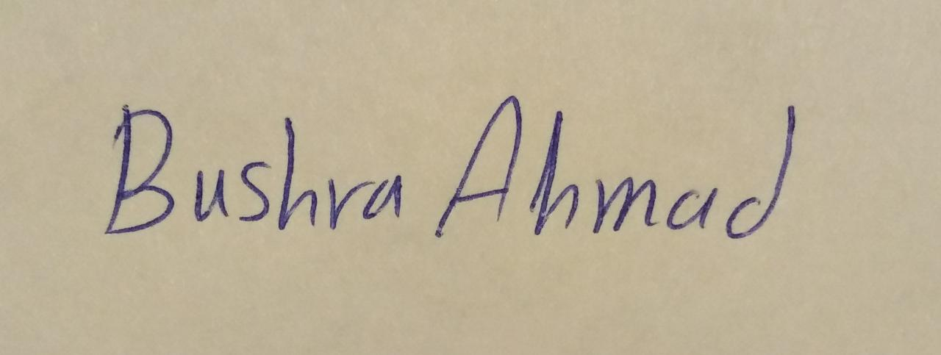
Sarukh Sultan | 23/05/2021 | 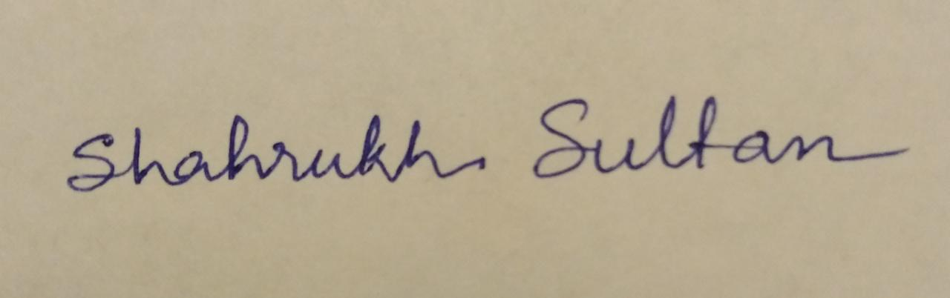

_____________ (( OnMyWay_))_______________________

FINAL STATEMENT OF WORK

SOW-23/05/2021

St. Petersburg / Санкт-Петербург
2021

Teacher
Filippov Evgeny Vasilyevich / Филиппов Евгений Васильевич e.philippov.leti@mail.ru
Ерошкин Александр Владимирович
a.eroshkin@sigma-it.ru

History

 | Date | Short description
SOW -1- | 04/03/2021 | 1-Name of project  2- Idea of project
SOW -2- | 18/03/2021 | - Project Description  - Basics of development  - High level Architecture
Final SOW | 23/05/2021 | Final Implemantaion App

Project team

№ | Name | Group | Project role | Contact Information
1 | Bushra Ahmad | 6300 | All application | Bushraahmad407146@gmail.com  +79516522218
2 | Shahrukh Sultan | 6300 | All application | getssultan@gmail.com  +91 8638791167

Key milstones

№ | Start date | End date | Description
1 | 01/03/2021 | 18/03/2021 | Determine the project idea and requirements for its application and prepare the tools for its implementation
2 | 2021/03/21 | 2021/04/22 | Learn the Dart language and write the code for designing the user interface and application
3 | 2021/04/23 | 23/05/2021 | Connecting the application with the server, testing the code, and fully realizing the application
4 | 23/05/2021 | 24/05/2021 | Defense

BASIS FOR DEVELOPMENT /
Android studio/framework-flutter/language-dart/API server.
Full name of the project
OnMyWay_________________________________________________________________

DEVELOPMENT GOALS /
The software product is intended to people to give them chance in helping themselves_
If this idea is implemented well, we can reduce congestion and reduce car fuel consumption_______________________________________________________________________________

HIGH LEVEL REQUIREMENTS /
- Technologies used:
- Flutter: To develop the application framework
- Dart: To write the codes
- API Server and Database technologies

_________________________________________________________________________

Chosen technology and development framework /
In this application we use flutter as a framework and dart language for programing

DEVELOPMENT MODEL /
Development model :
We will use the following development model “Agile model”./

